1. Getting started with Technology

Working with Packet Tracer

**LEARN TO USE THE SIMULATION TOOL-CISCO PACKET TRACER**

**1.Learning objectives:**

* **Get acquaintance with CISCO Packet Tracer**
  + Two modes – Real & Simulation
  + How to create topology of a simple Local Area Network ?
  + How to configure?
* Play in Real mode
  + How to test ?
  + **IP Address : Basic rules & Playing around subnet mask**
* Play in Simulation mode
  + Events
  + See how packets move.
  + Get a feel of layers
  + **How to analyze a Protocol Data Unit/Packet?**
* Difference between the simulation types – ‘**Auto capture / Play’ & ‘Capture forward’**

**2.Topology**

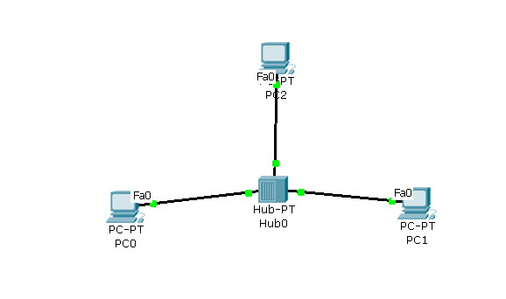

**3.Conduction**

**PartA. Select ‘Real mode’(Default mode is Real mode)**

|  |  |  |  |
| --- | --- | --- | --- |
|  | **do** | **What to observe** | Write down / Answer the question |
| 1 | Set up the network as shown in the diagram using a HUB |  |  |
| 2 | Configure IP addresses  PC0 : 1.1.1.1  PC1 : 1.1.1.2  PC2 : 1.1.1.3 |  | **How many interfaces are available in PC0?**  **Ans :**  **What is the name of the interface?**  **Ans :**  **How many interfaces are there in HUB ?**  **Ans :** |
| 3 | Ping from PC0 to PC1  Ping from PC1 to PC0 | Result : Success or Failure ? | **Ans :** |
| 4 | Change the setting of PC1’s interface to FULL DUPLEX mode |  | **What is the observation**  **Ans :** |
| 5 | Set it back to ‘HALF DUPLEX ‘ mode. |  | **Ans :** |
| 6 | Set the IP address of PC1 to 2.2.2.2 & PING between PC0 & PC1 | The status | **What is the observation ?**  **Ans :**  **What could be the reason ?**  **Ans :** |
| 7 | Set it back to 1.1.1.2 |  |  |
| 8 | Change the bandwidth of one of the ports of HUB |  | **What is the observation ?**  **Ans :** |
| 9 | Keep the cursor on PC0 | IP address | **Write down the IP address, as displayed**  **Ans :** |
| 10 | Change the subnet mask of PC0 to 255.255.0.0;  Keep the cursor on PC0 | IP address | **Write down the IP address, as displayed**  **Ans :** |

**Part** B**. Select ‘Simulation mode’**

|  |  |  |  |  |  |
| --- | --- | --- | --- | --- | --- |
|  | **Do** | | **What to observe** | | Write down / Answer the question |
| 1 | Ping from PC0 to PC1  &  **Click Auto capture & Play** | | Movement of the packet | |  |
| 2 |  | | Event list | | **How many events have occurred?**  **Ans :** |
|  |  | |  | | **How much time is taken to complete pinging task ?**  **Ans :** |
|  | |  | |  | **What is the name of the protocol ?**  **Ans :** | |
|  | | Analyse the first packet  **Click on the info field of the first row in the event** | | PDU Information at device PC0 |  | |
|  | |  | |  | **How many layers are active out of 7 layers ?**  **Ans :** | |
|  | | **Click outbound PDU details** | |  | **How many fields are there in the link layer ( Ethernet) frame ?**  **Ans :** | |
|  | |  | |  | **How many fields are there in the ICMP packet ?**  **Ans :** | |
|  | |  | |  | **What is value of TTL in the IP header ?**  **Ans :** | |

**4..Post-Laboratory assignment** ***( to be written in the observation book, before entering the next lab ]***

1. Explore 2 differences between SIMULATOR & EMULATOR
2. Name at least 3 popular simulators & Emulators